Multidimensional Volume as a Research Abstraction: A Geometric Model of Valid Description with Nonlinear Approximation and Noetherian Semiotic Symmetry
Model 5

Appendix to the project Theory of Physical Measurement of Value (TPMV)

Author: Eist Alexander Georgievich / ORCID 0009-0006-3273-7770
Date: April 15, 2026
Version: 1.5 (Structural Framework)
Zenodo Community: phmv
DOI: [to be assigned]

Abstract
This paper provides a formal justification for the conventional nature of choosing dimensionality and coordinate systems when modeling physical systems within the semiotic framework of PhMV (Physical Measurement of Value) and PTV (Physical Theory of Value). A scalable geometric model of multidimensional volume V(n) is proposed, in which the Valid Description Volume (VDV) is defined by analogy with the volume of an n-dimensional sphere approximated by inscribed and circumscribed polytopes. As dimensionality n increases, the absolute value of VDV(n) is refined nonlinearly (the interval [VDV_{min}(n), VDV_{max}(n)] narrows).
A new parameter, Semopia Σ(n), is introduced — the semiotic invariant of linear Noether symmetry applied to the space of concepts and recursive memory addressing in accordance with the Second Law of Semiotics. The model is consistent with the principles of balancing informational (I) and energetic (E) resources for goal achievement.

1. Axiomatic Justification of the Conventional Nature of Measurements

1.1. Basic Axiom on the Nature of Description

Axiom 1.
The choice of the number of dimensions n and the coordinate axes is a research method of reduction — a simplification of the model of the object that does not belong to the object itself. Continuous reality by default contains no divisions into separate objects and their discrete properties (First Law of Semiotics).
Corollary 1.1. We operate with description (model), whose validity is determined by the observer’s goal, rather than with objective data (denotat).

1.2. Noetherian Semiotic Symmetry

1.2.1. Second Law of Semiotics
A word is an address in memory, and as a direct consequence, the content of any memory can itself be an address to another memory. This establishes the fundamental recursiveness of semiotic space.
Noether’s Theorem (semiotic formulation): If a description model is invariant under continuous linear transformations and recursive addressing in the space of concepts, then there exists a conserved semiotic invariant — Semopia Σ(n).

1.3. Implications for Modeling

- Any n-dimensional representation is a projection of a continuous continuum onto a chosen conceptual basis.
- The transition n↔n±1 reflects a change in the level of detail and the addition/removal of a layer of addressable memory.
- The adequacy of a description is determined by the geometric accuracy of the VDV approximation.

2. Geometric Model of Multidimensional Volume

Definition 2.1. Multidimensional volume of a description:
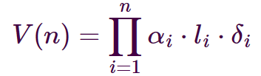

Definition 2.2. Valid Description Volume (VDV):
VDV(n) is the geometric volume of the valid description region in n-dimensional conceptual space, approximated by the volume of an n-dimensional polytope, where n corresponds to both the number of dimensions and the parameters of the approximation.

- VDV_{min}(n) — volume of the inscribed polytope (lower accuracy bound);
- VDV_{max}(n) — volume of the circumscribed polytope (upper accuracy bound).

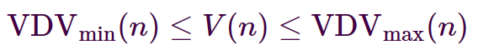
Thus:
Key Property: As n increases, the interval [VDV_{min}(n), VDV_{max}(n)] narrows nonlinearly, and the ratio VDV_{min}(n) / VDV_{max}(n) → 1 (analogy with the refinement of the sphere’s volume as the number of faces of the approximating polytope grows).

Definition 2.3. Spatial entropy of the description (Boltzmann connection):
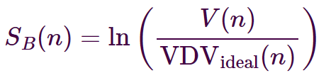

where VDV_{ideal}(n) is the geometric mean of VDV_{min}(n) and VDV_{max}(n).

2.4. Quantization as the Mechanism of Semiotization
The process of translating default-continuous Reality into a discrete description is called Quantization.

Definition 2.5. The size of the model quantum Q(n) is defined as the area of a geometric face of the n-dimensional polytope (or the edge length in the two-dimensional case).
Quantization simultaneously provides:
2.5.1. A seamless transition between dimensionalities of multidimensional volumes (only the number and size of faces change).
2.5.2. Semiotization of continuous reality: each face becomes a discrete symbol-description.

A detailed development of the Quantization concept is planned in the next work of the project.

3. Semopia as the Semiotic Invariant

Definition 3.1. Semopia Σ(n) is the semiotic invariant of linear Noether symmetry in the space of concepts. It quantitatively measures the normalized rate of change (steepness) of the ratio of the current description volume to the ideal valid region, weighted by the size of the model quantum:
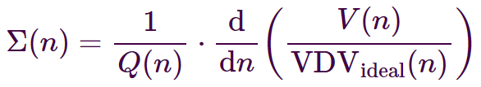

Recursive form (for practical use):
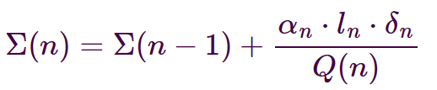

Properties of Semopia:
- Provides linear scalability independent of the number of dimensions.
- Allows the effective volume of the denotatum to remain constant: V(n) · Q(n) ≈ const when accuracy δ varies (δ is inversely proportional to Q(n)).
- Connection with spatial entropy:
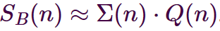

4. Scaling Examples

n | V(n) | S(n) | Definition
1 | (l·δ) | (l·δ) − 1 | Line
2 | (l·δ)² | (l·δ)² − 1 | Surface
3 | (l·δ)³ | (l·δ)³ − 1 | Volume
4 | (l·δ)⁴ | (l·δ)⁴ − 1 | 4-dimensional
… | ... | ... | …
n | (l·δ)^{n} | (l·δ)^{n} -1 | n-dimensional

5. Connection with the Theory of Physical Measurement of Value

The model naturally aligns with the axiomatic basis of PMV:
- VDV reflects the balance of informational and energetic resources.
- Semopia formalizes the principle of sufficient accuracy for the goal through linear symmetry of concepts.
- Quantization completes the transition from continuous reality to discrete observer-dependent descriptions.

Conclusion

Model 5 of the multidimensional volume is presented, featuring geometric approximation of VDV, the introduction of Semopia as a linear semiotic invariant, and the Quantization mechanism. This opens the way to algorithmic selection of optimal dimensionality and accuracy under limited resources for goal achievement.

Key Terms
- Valid Description Volume (VDV)
- Semopia Σ(n) — semiotic invariant of linear Noether symmetry
- Quantization — the process of semiotization of continuous reality through the face area of a polytope
- Description vs. data

Reference to the main project

Common Foundation: Semiotic and Methodological Groundwork for the Theory of Physical Measurement of Value
url: https://zenodo.org/records/18470990
DOI: 10.5281/zenodo.18470990

